Web Automation (IS and Apps) - Automated Test Execution Guide
For Script v3.x
Author: QA Web Automation Team

Table of Contents
1 Table of Contents 2
2 Introduction 3
3 Environment Setup (first few things before setting up the automated tests on new machine) 4
3.1 OS supported 4
3.2 Browser installations 4
3.3 Display settings 5
3.4 Katalon Studio version? 5
3.5 WebDriver updates for Katalon Studio? 6
3.6 Other library updates for Katalon Studio? 6
4 Opening Automation project in Katalon Studio: 8
5 Execution Settings Within Katalon Studio 9
5.1 Global Variables 9
5.2 Some regularly used/edited variables 9
5.3 Variables related to TFS Test Management integration (in effect when integration setting is ON) 10
6 TFS Test Management integration for reporting 12
7 Analyzing the test reports 14
7.1 Test Execution Log in Katalon 14
7.2 Test Execution Report Folder 15

Introduction

- This document explains operational factors to be considered before/during execution of Automated tests for Ideal Spaces and other Apps (which are using the common Web Automation framework being developed for IS).
- Almost all the instructions are directly referring to Ideal Spaces related test execution, and with slight adjustments, for other apps.
- The reader is expected to be aware of concepts/basics of Test Automation + Katalon Studio tool + Selenium and WebDriver, to some extent. So it may be useful if you spend a day or two to explore these aspects. After that and while exercising the instructions if you face any roadblock, please contact QA automation team members for further assistance.

Environment Setup (first few things before setting up the automated tests on new machine)

OS supported
- Currently, our tests can execute on Windows and Mac platforms.
However, Win 10 is primary platform for test development and regular tests.

Browser installations
- Ensure that the browser for which automated tests need to be executed, is installed on the OS /machine.

Note:
Chrome is currently the preferred browser under which all automated tests are developed and verified. They are normally runnable in Firefox as well with a few exceptions. We have limited support for Safari and Edge, and for some tests.

- For Safari on Mac:
  - Ensure that “Enable Remote Automation” option is chosen.
  - Ensure that no “Open” instances of Safari exist, before triggering the automated tests.

- For Edge on Windows 10:
  - Ensure browser data is cleared at the time of browser exit, so that new session is fresh always (fresh session is needed for Automation). To achieve this, enable below option:
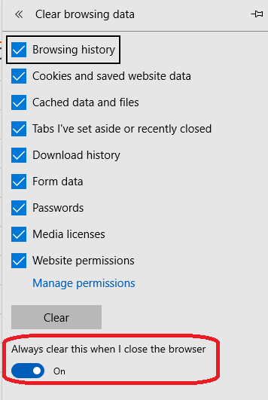

  - Ensure that no “Open” instances of Edge exist, before triggering the automated tests.
  - Finally, ensure if MicrosoftWebDriver is available with installed Edge version.
<To be Elaborated>.

Display settings
- Resolution of the machine should be: 1920 X 1080
- Additionally, if any scaling is applied to UI, revert it to default.
E.g. Make Scaling factor = 100 % on Win 10

Below screenshot shown for Win 10
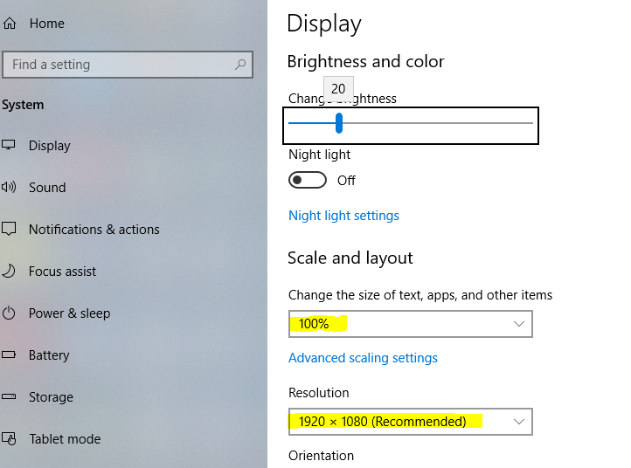

Katalon Studio version?
- It is recommended to use the same Katalon studio version which is used by QA Automation team for Automated Test Development. This is to avoid any (possible) issues arising due to project/Katalon studio structural changes due to different Katalon studio versions.
  - In case of difficulty in finding the expected Katalon Studio version setup, you can contact QA Automation team members for the one. The setup folder can also be found at:
\\pc-win7qa64.apac.wan.2020.net\QA Web Automation\Builds

  - Over the internet, older versions can be found here:
https://github.com/katalon-studio/katalon-studio/releases

- If at all it is urgently required to obtain the Katalon Studio setup, you can get the latest version from Katalon studio official site, and use it to fulfil the emergency requirement.

WebDriver updates for Katalon Studio?
- Katalon studio being used for automation test execution/development, may not always have latest WebDrivers. So based on your app’s need, it may require a manual upgrade.
- For Ideal Spaces, the current strategy is to execute the automated regression tests on recently released browser.
Note: There will be separate instruction if tests on Beta browsers are to be executed. A relevant WebDriver update need to be manually verified before triggering the tests.
- If you obtain the Katalon Studio setup folder from QA automation team, normally you will receive Katalon setup with expected WebDriver versions being used for recent Ideal spaces regression tests.
- However, if you want to upgrade/downgrade the WebDrivers yourself (based on your application’s needs), the WebDrivers are located in Katalon Setup folder here:
..\Katalon_Studio_Windows_64-5.10.1\configuration\resources\drivers
- All in all, you can consult with QA Automation team for general approach to be followed for your app.

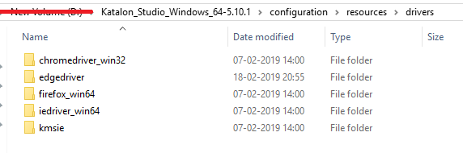

Other library updates for Katalon Studio?
- Katalon studio being used for automation test execution/development, may not always have latest libraries (e.g. selenium-standalone-server jar). So if the app tests require a library upgrade, it needs to be done from below location:
..\Katalon_Studio_Windows_64-5.10.1\configuration\resources\lib\
- If you obtain the Katalon Studio setup folder from QA automation team, normally you will receive Katalon setup with expected libraries being used for recent Ideal spaces regression tests.
- All in all, you can consult with QA Automation team for general approach to be followed for your app.

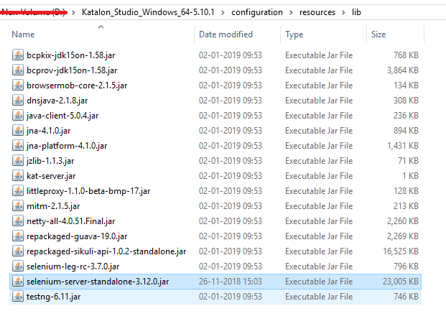

Opening Automation project in Katalon Studio:

- QA Automation Team stores the Ideal Spaces automation code in TFS at below location:
  - $/QA Automations/IdealSpacesAutomation/IdealSpaces 6.0/Script v3.x
  - Script v3.x is the Katalon Project folder.
  - Latest code can be obtained from this TFS location.

Important Note:
Please avoid doing any kind of check-in at above location.

- However, latest code may not have been tested from our end always.
  - So if you need a project setup folder which is recently tested, choose a one and copy it to your machine. This location is sort of “Automation Build Repository”.
  - Builds: \\pc-win7qa64.apac.wan.2020.net\Builds\Local Builds
  - Do not rename the folder after copy, because the name contains important information with respect to TFS Check in no.
  - In case of doubt (i.e. which build version you need to choose), please contact QA Automation team.
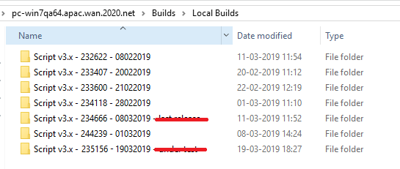
- Naming convention is:
  - <ProjectFolder> - <TFSCheckInNo> - <DateStamp>

- Note:
On Mac, ensure to setup Sikuli library separately.

Execution Settings Within Katalon Studio

Global Variables
- Global Variables are stored in Profiles.
- For IS 6 test automation, there is profile per tenant app.
- While running test/test suite, selection of profile for right tenant/customer, is important.
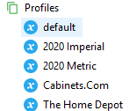
- While editing the values in Profiles, Do Not change the variable data type.
- To understand the purpose and instruction about a variable, you can refer to “Description” column under profiles.
  - Some variables are for internal purpose. They should not be edited.
  - Some can be edited.
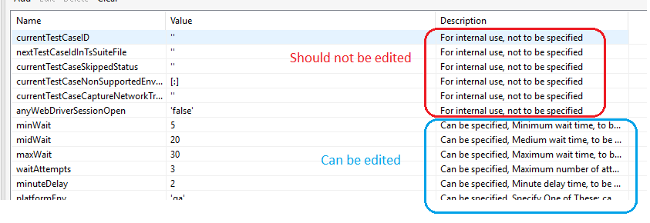

Some regularly used/edited variables
- platformEnv
  - This flag can be set with following values:
  - Flag pre-prod is to be used with another flag useUrlFromPlatformLauncherOverUrlFromSpreadsheet set as false.

- useUrlFromPlatformLauncherOverUrlFromSpreadsheet
  - Setting this flag to “true” will launch the IS URL from Platform Launcher compulsorily, on specified environment.
  - Setting this flag to “false” will launch the IS URL specified in the XLS sheet.
This excel sheet is placed in .\Script v3.x - .….\Data Files\App-Urls.xlsx
- So if you launch the URL from this xlsx, please ensure that the xls is containing right URL.
    - We use this flag as “false” only for Pre-Prod execution.

- chromeBetaToUsedOnWindowsExecution
  - If the test execution is to be carried out on Chrome beta + Windows, this flag needs to be set as “true”.
  - When set to “true”, the scripts also require the “chrome beta binary” path, which is specified in another Global variable called chromeBetaBinaryPathOnWindows.
  - This variable holds the chrome beta binary (or .exe) file path.
  - Important: If the test execution is to be carried out any other browsers, this flag needs to be set as “false”. So this flag is only required for Chrome Beta, and on Windows.
For any other combination, set this flag to “false”.

- enforceNewBrowserSessionForEachTestCase
  - Setting this flag to “true” always enforces a new browser session for every test case, regardless of session sharing is enabled or not.

Variables related to TFS Test Management integration (in effect when integration setting is ON)

Note: Section 6 seprately explains how to enable the TFS Test Management integration.
So below variables will be in effect when integration is enabled.

- tfsSuiteHierarchy
  - Comma separated list can be specified. Below flags are supported.
  - Based on this list, a hierarchy of test suite containers will be created in TFS.
This hierarchy can be useful to group together the execution reports based on various categories indicated by flags above.
  - Example (Demo Metric):
The first container in TFS will be test suite name, followed by profile which is customer name. So result in TFS:
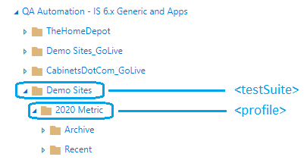
  - As you can notice, once the hierarchy is created, at the end, it will have two default containers viz. Archive and Recent. The result of current test execution goes into Recent category/container.

TFS Test Management integration for reporting

- TFS Test Management integration is a capability to push the execution results to TFS.
- In order to push the results to TFS, the integration setting needs to be enabled.
- Always ensure to turn the ignoration OFF when you are experimenting/debugging the scripts.
This will ensure to avoid unnecessary results being pushed to TFS.
- The related settings file is present here in the project folder.
.\Script v3.x - .…. \External Libraries\tfsIntegration.properties
  - Note the difference between tfsIntegration.properties and tfsIntegrationTemp.properties.
  - tfsIntegrationTemp.properties is an internal file, and should not be edited.

- To enable integration:
  - Open tfsIntegration.properties in notepad.
  - Set the value of tfs.integrationEnabled = true.
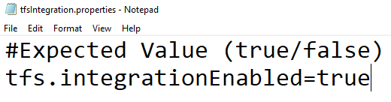
  - To push the results to TFS, you may need authorization access.
- On Windows, if you are logged in with your TFS recognized user/domain user, authorization is implicit and token (explained below) is NOT required. This situation may change with VSTS/AzureDevOps though.
- Otherwise, you can provide “Personal Access Token (PAT)” to ensure the authorization.
- Care to be taken while working with tokens:
  - Since token is your identify, please use this token wisely, and only when necessary.
  - Do not assign the token full rights but only the necessary ones.
  - Also, you can remove the rights when token is not in use.
  - It is recommended not to share the token with many people, and not to check-in the same in TFS. It can be setup just in time during the test execution.
  - To push the execution results to TFS, you need below two rights for your token:

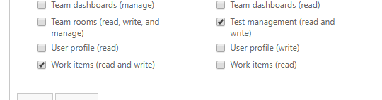

  - To know more about PATs, refer this link.
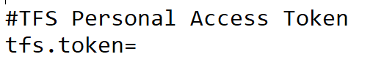

Analyzing the test reports

Test Execution Log in Katalon

When the Test Execution completes in Katalon (when run from Katalon UI), normally the logs are used to analyze the overall status. The logs will display which tests have Passed, and which have Not Passed (Error, Failure etc.).
Sample log report below:
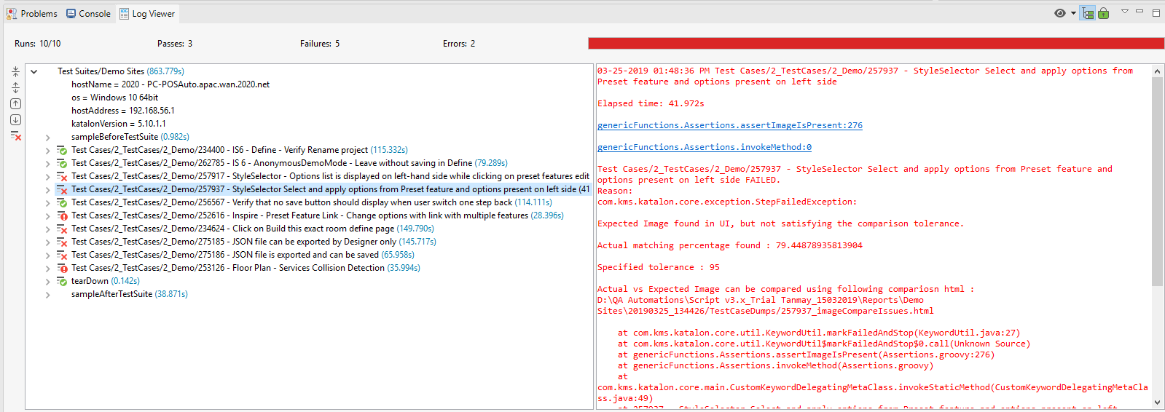

- The tests appearing with green tick mark are passed.
- The ones with red mark are failed/facing error (red cross: failed, red exclamation: error)
- Click on the non-passed test and it will most likely demonstrate more information about the failure in red text (right pane). Some common caused of failure are:
  - Object properties got changed (xpath, id, class etc).
  - Expected Image not found/not found with matching percentage
  - Functional defect in App
  - Pre-requisite test data missing

The failure information in Katalon will provide you some hints/important information w.r.t. failure type. The actual steps required to be taken after that, is context specific decision and can be taken at that time.

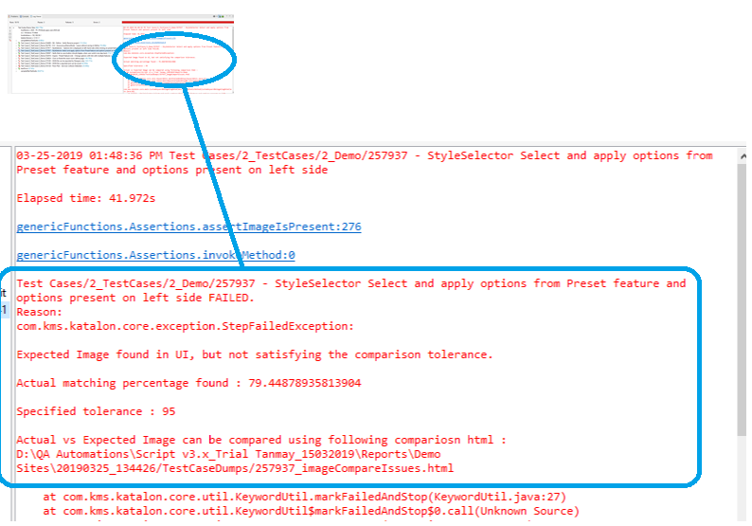

Test Execution Report Folder

- Report folder for Test Suite - This is generated within the Katalon Project level Report folder.
- Report folder for Test Case - This is generated within the “%temp%\Katalon\Test Cases\....”

When working with a Test Suite:
To navigate to expected report folder, see below screenshots.
  - Observe the yesy run no. in Katalon, and find it in Report section in Katalon. Right Click on it and say “Open Containing Folder”.
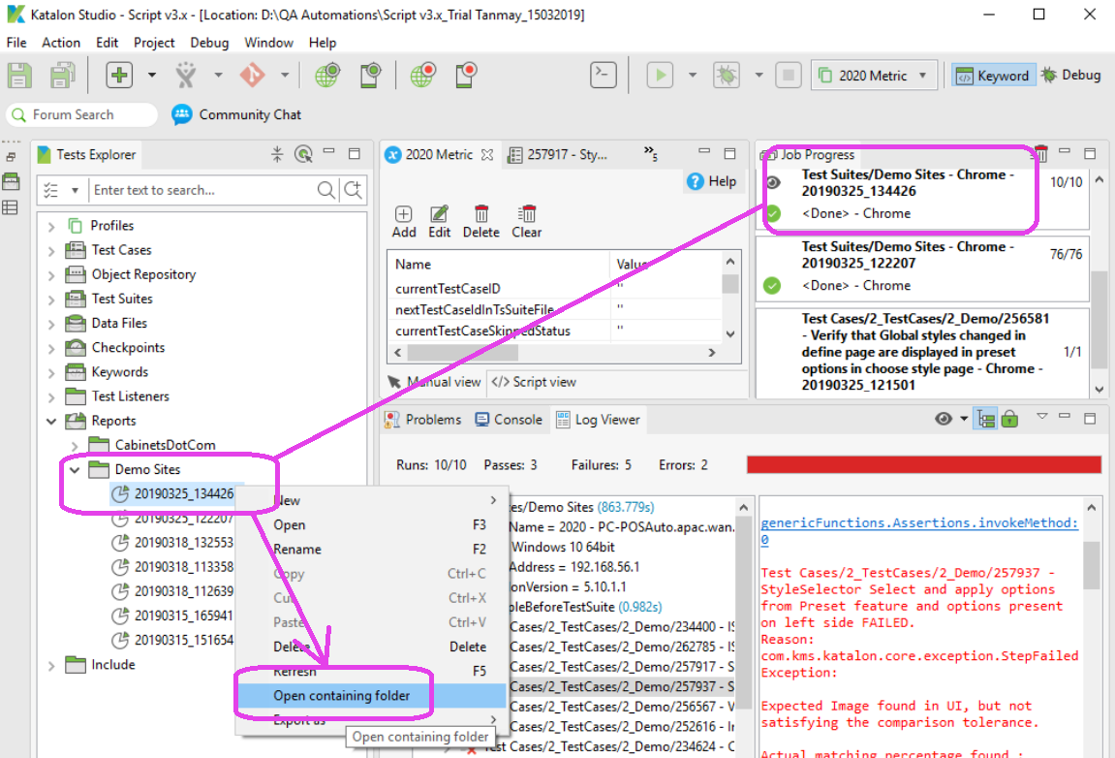
  - Open the run folder.
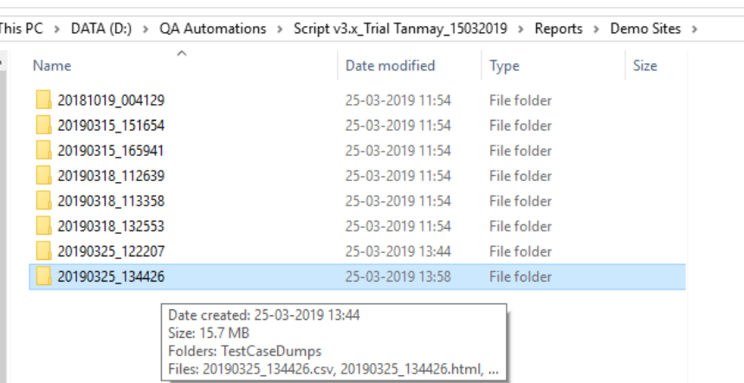

  - This folder will contain html report (log transformed into html report).
The same folder will also contain another folder called “TestCaseDumps”.
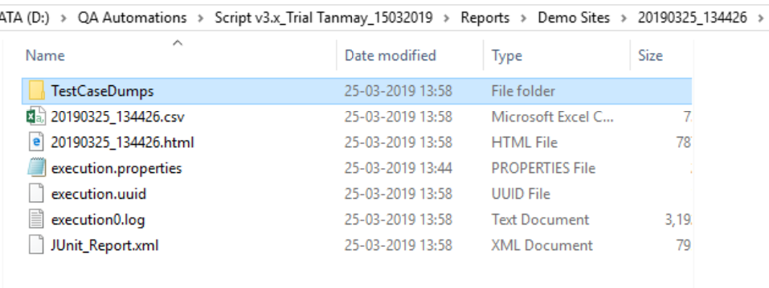

  - “TestCaseDumps” folder will normally provide the screenshots at the time when test failed.
It will also have the html report for tests which failed due to html comparison (this report will be per test).

These screenshots are useful to know the state of UI at the time of failure, and can give very good clues about why the test failed.

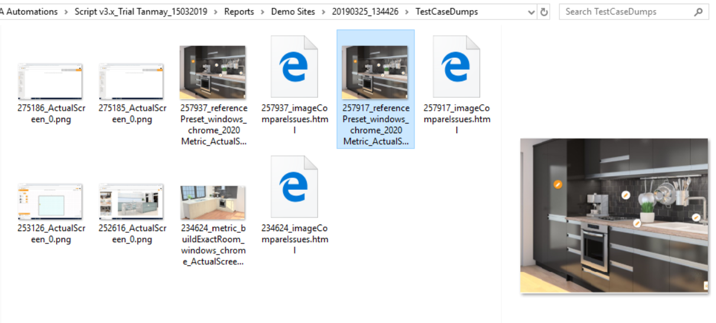

When working with a Test Case:
Just find the test case report folder, and other steps are same as above.

